
American Battery Solutions Inc.

Software Configuration Management Plan
Document ID:0179 | Release Date: 7/29/2025
Revision: 1.2 | Document Owner: Director, Battery Management Systems

(c) [2019] [American Battery Solutions]; all rights reserved. This document may contain proprietary information and may only be released to third parties with approval of management. Document is uncontrolled unless otherwise marked; uncontrolled documents are not subject to update notification.

Table of Contents
1 Introduction & Purpose 2
1.1 Terms & Definitions 2
2 Application and Scope 2
3 Responsibilities 2
4 Configuration Management Strategy 2
4.1 Tools and Repositories 3
4.2 Access Rights 4
4.3 Configuration Item Identification 4
4.4 Project Folder Structure 4
4.5 Project Management 5
4.5.1 Requirements and Change Requests 5
4.5.2 Tasks 5
4.5.3 Defects 6
5 Configuration Management Workflow 7
5.1 Feature Branch Statergy 9
5.1.1 Creating Branch 9
5.1.2 Change History 9
5.1.3 Commit Messages 9
5.1.4 Peer Review 9
5.1.5 Branching, Rebasing and Merging 10
5.2 Baseline Definition and Strategy 10
5.2.1 Tag Naming Convention 11
6 Naming Convention 11
7 Release Management 12
7.1 Release Types and Names 12
7.1.1 Production Releases 12
7.1.2 Engineering Drops 12
8 Configuration Status Report 12
9 Backups and Archiving 12
9.1 Project Backups 12
9.2 Disaster Recovery 12
9.3 Archiving Policy 12

- Introduction & Purpose
The purpose of the Configuration Management Process is to establish and maintain the integrity of all work products of a process or project and make them available to affected parties.

The Configuration Management Process covers the identification of configuration items and covers the definition, creation, and verification of baselines.

  - Terms & Definitions
Acronym | Definition
CI | Configuration Item
CM | Configuration Management

- Application and Scope
The scope of this document applies to software development and the process of configuration management.

- Responsibilities
The Configuration Manager (role) is responsible for:
- Create, Update, Approve CM Plan
- Identify CIs
- Ensure stakeholders are trained
- Participate in release reviews
The Program Manager is responsible for:
- Maintain Project Plan
- Review project milestones with Configuration Manager
The Software Team is responsible for:
- Ensure compliance to CM plan
- Complete, Review and Release baselines
The Quality Team is responsible for:
- Perform baseline checks and audits.
- Provide support in training

Procedure
- Configuration Management Strategy
The Configuration Management Strategy identifies the approach from the initial kick-off throughout the lifecycle of a project. It identifies the approach and how the CI’s will be managed for all BMS software projects. It identifies the tools that enforce our workflows (automated or partially automated), details of requirements gathering and attribute assignments, configuration items, naming conventions, branching, and merging strategy.

  - Tools and Repositories
Bitbucket is the tool of choice for Configuration Management. It is a part of our overall Engineering Infrastructure and integrates/interfaces to other engineering tools to support full traceability.

Current Project List:
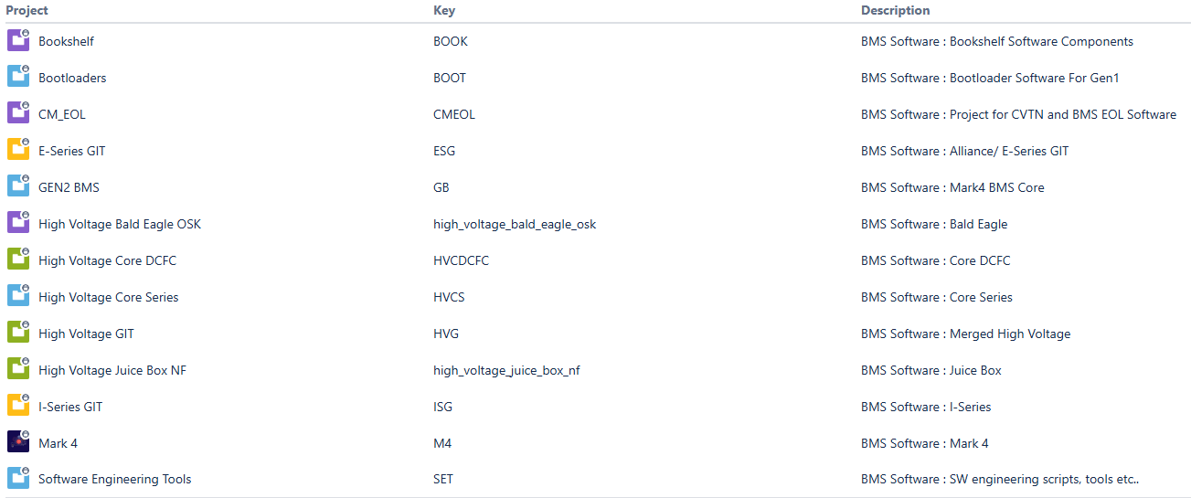

Current Repositories:
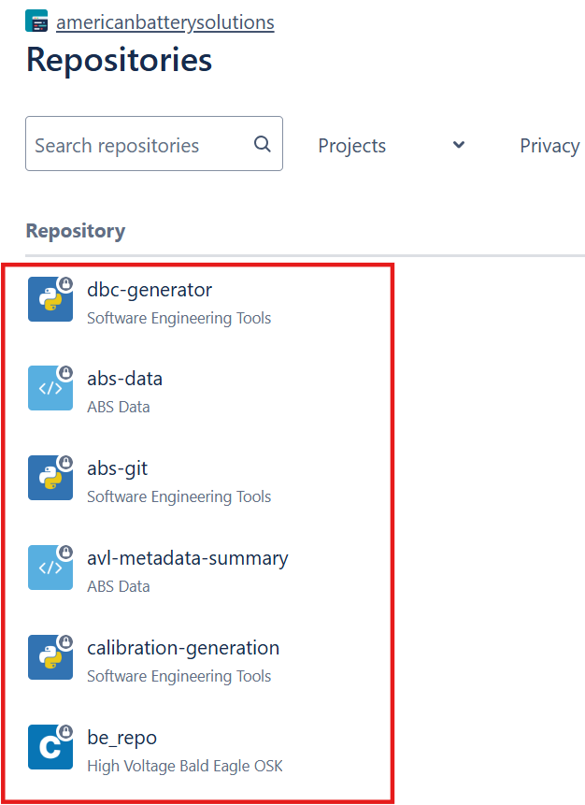

  - Access Rights
Bitbucket access is granted by ABS IT Administrator as part of the onboarding process and/or at the start of a new project.

  - Configuration Item Identification
At a minimum the following shall be included in the release baseline:
- Project Specific Documents
- Software Plans
- Source code
- Development tools
- 3rd party software
- Architecture & Design
- Test cases and results (Test cases can reside in Jira but must be traced to the baseline).

  - Project Folder Structure
All tools, source code, and documents related to project development shall be archived in Bitbucket project. The highest levels of the directory structure are created and maintained by the configuration manager and are not under the control of the software teams. Subfolders may be added if required and approved by the Software Lead.

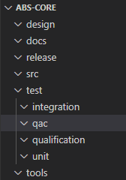

design ← Architecture and Detailed Design
docs ← Project specific documents
release ← Release Binaries, Release Notes.
src ← Source code for application, bootloader etc.
test ←
- qac ← QAC project and Static Analysis Reports, Metrics Reports.
- unit ← Unit test scripts, test specification and results
- integration ← Integration test scripts, test specifications and results
- qualification← Qualification test scripts, test specification and results
tools ← Project Specific Tools

  - Project Management
Jira is used for project management. Supported work types in Jira are 1) Software Requirement / Sub-
System Requirement 2) Task and 3) Defects. These work types are used for scheduling, by assigning it to a “Release” in Jira.
    - Requirements and Change Requests
Requirements and Change Requests are managed in Jama by the Systems team. These Jama items are pulled into Jira as a ‘Sub-System Requirement’ or ‘Software Requirement’. Requirements follow Requirement Implementation workflow as shown below,
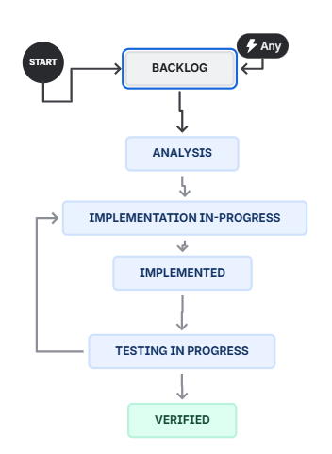
    - Tasks
Tasks are managed in Jira by the Software team. The tasks are used to create software activities. Requirements follow Task workflow as shown below,
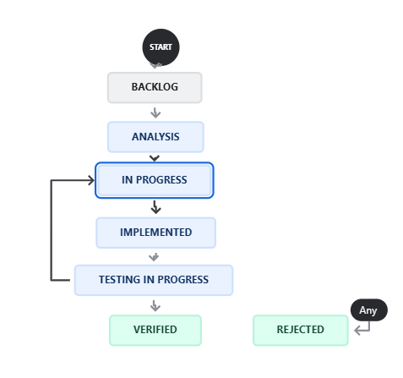

    - Defects
Defects are created in Jira when the software does not meet the requirement. Defects follow ABS Problem Management Resolution Statergy workflow as shown below,
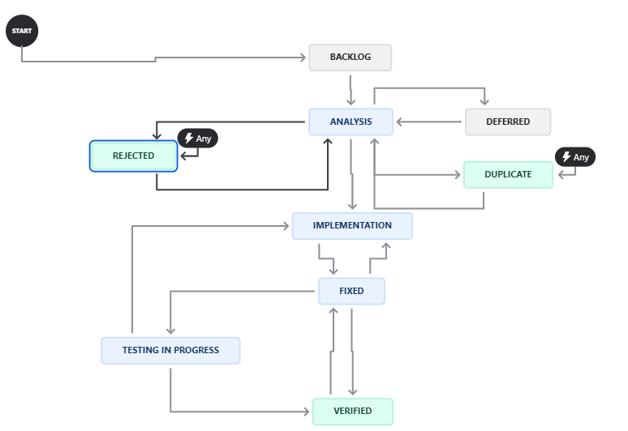

- Configuration Management Workflow
We will follow the “Git Flow” Workflow defined for Git and Bitbucket users.

The Git Flow Workflow assumes a central repository, and main represents the official project history. Developers create a new branch every time they start work on a new feature or bug fix from the develop branch. Developers are not allowed to create branches directly from the main branch. This flow eliminates buggy code from the main branch.

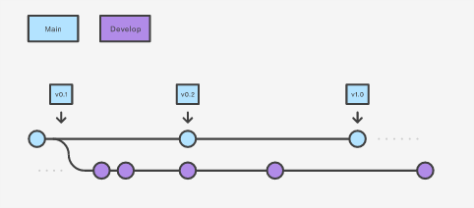

- The main branch stores the official release history.
- The develop branch serves as an integration branch for features and bugfixes.

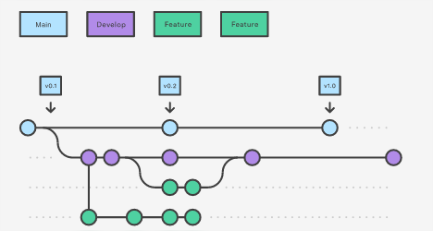
- feature and bugfix branches should have descriptive names and are based off the develop branch.
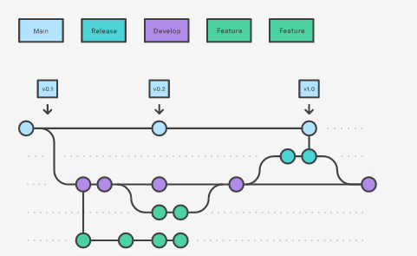
- Release Branch - Creating this branch starts the next release cycle, so no new features can be added after this point—only documentation generation, and other release-oriented tasks should go in this branch. Once it's ready to ship, the release branch gets merged into main and tagged with a version number. In addition, it should be merged back into develop, which may have progressed since the release was initiated.
- The release branch will be always handled by the software lead of the project.
- Start the release branch use command: git flow release start <RELEASE TAG>
- After all the release related changes are completed, it can be merged main and develop using command: git flow release finish <RELEASE TAG>

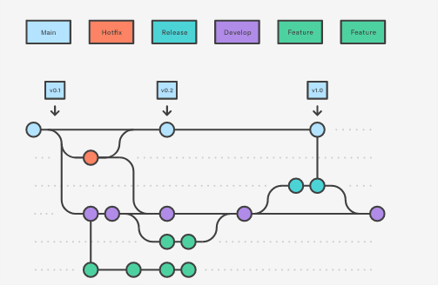

- “hotfix” branches are used to quickly patch production releases.
- “support” branches can be created to provide test software

  - Feature Branch Statergy
    - Creating Branch
Developers shall create and check out a feature branch in the appropriate repository where the task is to be implemented. The branch shall be directly created from the Jira work item’s Development tab as shown in the snapshot below,
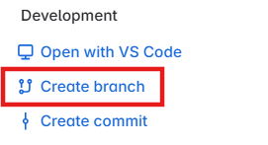

Branch name should start with prefix ‘feature/’ or ‘bugfix/’, followed by the Jira work item ID, / and descriptive name.
e.g.: feature/M4-26/CreateInitialProjectStructure. Or bugfix/M4-01/InvalidSOCValueOnCAN
    - Change History
The change history is automatically managed by the configuration management tool Bitbucket. It maintains the following for each CI:
- Change Date
- Version Number
- Person responsible for the change
    - Commit Messages
Commit messages shall contain a clear description of the changes in the commit, and list any related Jira work type IDs, assumptions or deviations, Test status etc.

    - Peer Review
Once the implementation has passed unit testing and static code analysis, the developer will create a pull request in Bitbucket. This action initiates a code review process in Smartbear Collaborator Tool, which requires approval from at least two peers.
The pull request is gated by two conditions 1) Peer-Review Approval and 2) Successful Bitbucket pipeline Run. The changes will be merged to develop branch by Software Lead after this gate is passed.

      - Creating Pull Request
Smartbear Collaborator is the tool used for review. Collaborator synchronizes the bitbucket pull requests.
Pull request can be created directly from bitbucket cloud or VS Code (VS Code Create Pull Request) and complete it in Collaborator (Create Review in Collaborator).

Pull Request title starts with prefix Jira work item ID: and descriptive name.
e.g.: M4-26: Create Initial Project. Or M4-01: Fix for Invalid Soc on CAN

    - Branching, Rebasing and Merging
A feature branch should only address a single issue and is by default, owned by a single developer.

Feature branches only interact with develop - never other feature branches. Created on develop, rebased onto develop, merged into develop.

Rebase daily. If your feature branch takes longer, integrate the newest develop often to resolve conflicts quickly. The final merge will be easier to prepare.

Use rebase instead of merge to integrate the newest develop into your feature branches. The structure becomes clearer and there is no benefit from untouched git history when it contains no relevant info (merge commits develop → your feature branch).

Do not touch feature branches that don’t belong to you without the consent of their developers - since rebasing requires force pushing, your changes could be easily lost. Feature branches are there for development and are therefore subject to having their history changed and overridden.

Do not worry about WIP (work in progress) commits. Sometimes you may need to juggle between multiple issues in several branches or just want to have your work backed up, and git stash simply doesn’t cut it. With rebase and squash, your history is not final, so you can easily remove them later.

Squash redundant commits after it becomes apparent, they cannot be isolated. A single feature or smaller change should usually have a single commit. Imagine trying to revert a feature and only hitting half of the changes because there is one more commit hiding somewhere.

Prepare your feature branches for code reviews. This rule sounds like a direct contradiction to the previous one, but if it makes sense to submit a pull request with multiple commits - each reviewable separately - you should consider doing so. It simplifies the review process and therefore leads to better code. Changes based on code reviews should also have their own commits to simplify additional reviews.

Also prepare your branches for the merge itself - by squashing code review changes and performing a final rebase.

Remove unused branches. If a branch is in the repository, it is either being developed or is a backup of some important functionality. Name them accordingly and always remove branches that are no longer needed

  - Baseline Definition and Strategy
A baseline is a complete, immutable, and reproducible description of a project state with a unique identifier. Tags are ref's that point to specific points in Git history. Tagging is generally used to capture a point in history that is used for a marked version release (i.e. v1.0.1). A tag is like a branch that doesn’t change. Unlike branches, tags, after being created, have no further history of commits.
In Bitbucket this is obtained via “tags”.

Bitbucket supports two different types of tags, annotated and lightweight tags. Lightweight tags and Annotated tags differ in the amount of accompanying meta data they store. The best practice is to consider Annotated tags as public, and Lightweight tags as private. Annotated tags store extra meta data such as the tagger name, email, and date. This is important data for public release. Lightweight tags are essentially 'bookmarks' to a commit, they are just a name and a pointer to a commit, useful for creating quick links to relevant commits.

Annotated tags shall be used to identify “External Release” packages and Lightweight tags shall be used to identify “Internal Release” packages.
    - Tag Naming Convention
Tag naming in Bitbucket will follow this format:
<Project_Name>_<ABS Major>_<ABS Minor>_<ABS Customer ID><Release Type>

e.g. “CORE_00_01_08_05_REL” or “CORE_00_01_08_00_ENG”

- Naming Convention
Folder and file names must not contain additional characters, space or German special characters (e.g. $, §, %, &, “Space“, ä, ß …). To delineate a new word either use underscores (“_”) or capitalize the first letter of each word.

- Release Management
Releases are entered into SharePoint (Software_Release_Process Doc #0150)

  - Release Types and Names
    - Production Releases
Production releases are those that have been fully validated where any defects or risks are identified. <Release Type> shall be indicated by the keyword REL. These releases shall follow the (Software_Release_Process Doc #0150).

    - Engineering Drops
Engineering drops are those that have not been fully validated where defects and risks are unknown. <Release Type> shall be indicated by the keyword ENG. These releases are intended to be tested at a customer facility in parallel to ABS systems and validation testing.

- Configuration Status Report
Software Planning, Tasks, Change Requests and Defects are managed in Jira. As Configuration items are committed and tagged, Jira task status is automatically updated. Project management can view Jira Kanban board weekly as needed.

- Backups and Archiving
  - Project Backups
The complete project automatically takes part on the backup process of American Battery Solutions (ABS) IT Department. ABS IT performs incremental backups daily and full backups weekly.

  - Disaster Recovery
The disaster recovery is performed by ABS IT Department.

  - Archiving Policy
The ABS IT archiving policy will be followed for all identified configuration items.

Reference Documents
Software Release Process (#0150)

